


BURNET COUNTY EMERGENCY SERVICES DISTRICT NO. 2
P.O. Box 249
Buchanan Dam, Texas 78609-0249

Minutes (Official) – April 18, 2024

1.

(AI)1 Call meeting to order.

(AD)2At 6:00p.m., April 18, 2024, the Regular Meeting for the Board of Emergency Service
Commissioners of Burnet County Emergency Services District No. 2 was called to order by
President Sharon Barclay at the Cassie Volunteer Fire Department, 3900 RR 690, Burnet,
Texas 78611. Notice of this meeting (Enclosure 1) had been previously posted at the Burnet
County Courthouse and the Burnet County website, (Burnet County burnetcountytexas.org)

in compliance with the provisions of Chapter 551, Texas Government Code.

2.

(AI) Establish a quorum.

(AD) Board member in attendance were:
Sharon Barclay
Felicia Sanchez
Bill Proffer
Jodeen Lee- arrived at 6:14 p.m.
Robbie Cheatham – Absent
Commissioner Barclay confirmed a quorum was present. Commissioner Sanchez was
appointed Acting Secretary in Commissioners Cheatham’s absence.

3.

(AI) Pledge of Allegiance

(AD) The quorum having been established, the Pledge of Allegiance to the United States was
rendered with appropriate honors.

1
2

AI – Agenda Item
AD – Action and/or Discussion by BCESD-2Commissioners

Minutes

BCESD #2

April 18, 2024

1 of 31

4.
(AI) Invocation

(AD) Commissioner Barclay offered the Invocation.

5.

(AI) Welcome guests

(AD) Commissioner Barclay welcomed to the meeting:

CVFD Asst. Chief Schoenfeld
Mrs. Laura Schneider, CVFD Treasurer
Mrs. Megan Paz- BCESD 2 Administrative Assistant

6.

(AI) Comments for the Board and Public not scheduled on the agenda may be made.
However, no action can be taken on these items and the Board will not debate the
comments at this meeting. Comments regarding specific agenda items should occur
when the item is called. There is a 2-minute speaking limit.

(AD) Commissioner Barclay stated that the Joint Task Force meeting is next week and
reported sending out a SWOT Survey to assist in the formation of the Strategic Plan. This is
confidential and will be very helpful for everyone to complete it.

7.

(AI) Accept minutes from the March 29, 2024, Meeting

(AD) Commissioner Barlcay called for corrections to the March 29, 2024 Meeting Minutes:
with no additional changes the Minutes were accepted as presented.

8.

(AI) ESD #2 Treasurer Report

(AD) Commissioner Sanchez presented the Treasurer’s Report of March 2024.

Balances-

Checking: $300,300.80
Savings: $16,540.07
Texas Class Reserve Investment: $373,070.31
Texas Class Sales Tax Investment: $230,727.96
Total Assets: $920,639.14

Minutes

BCESD #2

April 18, 2024

Page 2 of 31

Total Income: $14,380.34
Expenses: $63,651.66

Net:
$-49,271.32

YTD Income $ 474,358.86
Budget $517,527.67
YTD Expenses $176,246.78
Budget $517,527.67
Net Income $298,112.08

Commissioner Barclay did note that we are over budget on our Tax Income and under
budget on Sales Tax. All expenses this month were anticipated expenses. Commissioner
Barclay called for any questions or corrections to the Treasurer’s Report, with no changes
the Treasurer’s report was accepted as presented. (Enclosure 2)

9.

(AI) Discussion and/or action regarding the disbursement of funds

(AD) Commissioner Lee reported that Cassie VFD received their quarterly disbursement and
that Megan Paz had received her March payment. The BCAD was paid last month.

10.

(AI) Report from the Cassie Volunteer Fire Department.

A. Report of VFD (Chief Curtis / Asst. Chief Schoenfeld)

1.
Number of calls

2.
Training, etc.

3.
Other department activity or concerns.

B. Cassie VFD Financial Report (L. Schneider)
C. Discussion and/or approval of Capital Expenditures for Cassie VFD, if
applicable.

(AD) Assistant Chief Schoenfeld gave the report on CVFD activity for the month of March
2024.
CVFD responded to 13 calls – 6 EMS / 7 Fire/Other. Mutual Aid – 5 given; 1 received.
There were 2 overlapping calls. Average response time for March was 6:46 minutes.

Minutes

BCESD #2

April 18, 2024

Page 3 of 31

In -District calls 6.31, M-F 5.83, Out of District was 7.35. The average personnel per call for
March was 5.6. (Enclosure 3)
B. Mrs. Schneider provided the CVFD Treasurers Report for March 2024. There was a
balance of $21,964.88 in checking. Expenses for March were $14,381.11, including expenses
for routine operations and training. Net Income YTD is $9,351.10. There was a
reimbursement for $156.00 from Cassie POA and was moved back into the operations
account.

Mrs. Schneider provided the CVFD Account Report- current balance is $117,497.83
March Total Expenses were $0 and Net Income is $9,351.10. (Enclosure 4)

11.

(AI) Administrative update of the Sales Tax Program for ESD No. 2. Including update

on reports from HdL.
(AD)Commissioner Barclay reported on the Sales Tax Income for April 2024. The income was
$7,867.00, which reflected a (- ).5% YoY. Commissioner Proffer spoke about the Eclipse Event
and questioned the tax rate that should be returned to us. It was noted that ESD 2 should receive
the 2% and we will know more when those funds are received approximately June or July 2024.
(Enclosure 5)

12.

(AI) Discussion and /or action related to Internet presence for BCESD2.

(AD) Commissioner Proffer presented information related to obtaining a domain name for
BCESD2. There was discussion related to the existing webpages and the advantages of
obtaining a .gov domain name. The Domain will direct our current existing webpages to that
.gov page.
Commissioner Barclay requested the motion to apply for domain name Burnetcotxesd2.gov.
Commissioner Lee made the motion to apply for domain name Burnetcotxesd2.gov.
Commissioner Sanchez seconded the motion. The was no further discussion and the motion
passed unanimously.

13.

(AI) Cybersecurity Training – Cybersecurity Awareness Training (youtube.com);

complete and send a letter documenting your compliance to Commissioner Barclay by May 15,

2024.

(AD) Commissioner Barclay noted that we have 2 people that have not completed the training
and asked for it to be completed soon; the deadline for submission is May 15.

Minutes

BCESD #2

April 18, 2024

Page 4 of 31

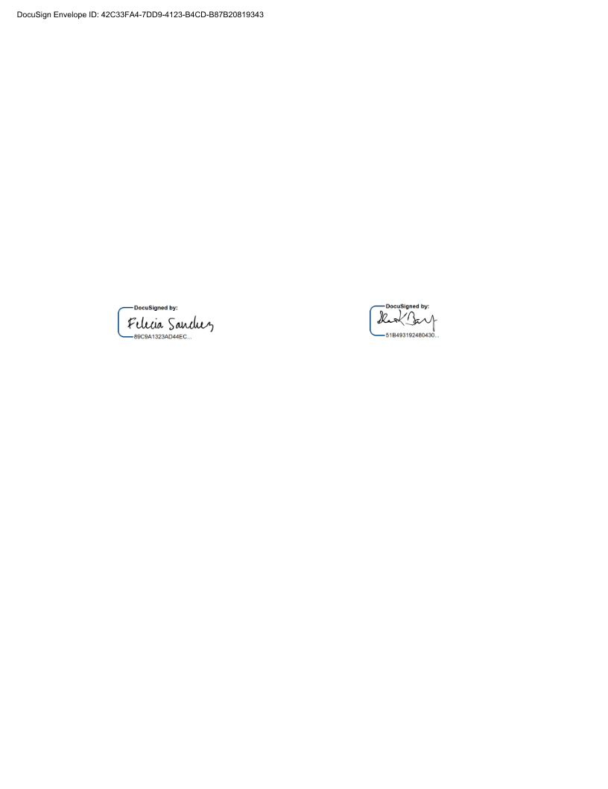
14.
(AI) Calendar of Events for May 2024

(AD) A. Standing Agenda Items

B. Renewal of SAFE-D Membership
C. JTF Report

15.

(AI) Next meeting, at 6:00 p.m. on Thursday, May 16, 2024.

(AD) With no additional business, the Burnet County Emergency Services District No 2,
April 18, 2024 Meeting was adjourned at 7:06 p.m.

Felicia Sanchez
Acting Secretary
Emergency Services District No. 2
Burnet County
April 18, 2024

Sharon K. Barclay
President
Emergency Services District No. 2
Burnet County
April 18, 2024

Minutes

BCESD #2

April 18, 2024

Page 5 of 31

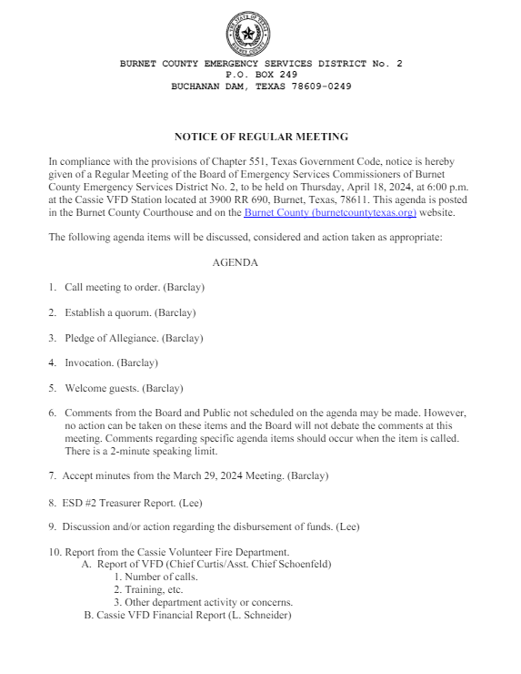
Enclosure 1

Minutes

BCESD #2

April 18, 2024

Page 6 of 31

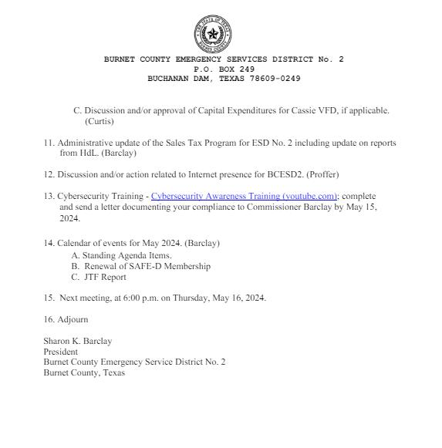
Minutes

BCESD #2

April 18, 2024

Page 7 of 31

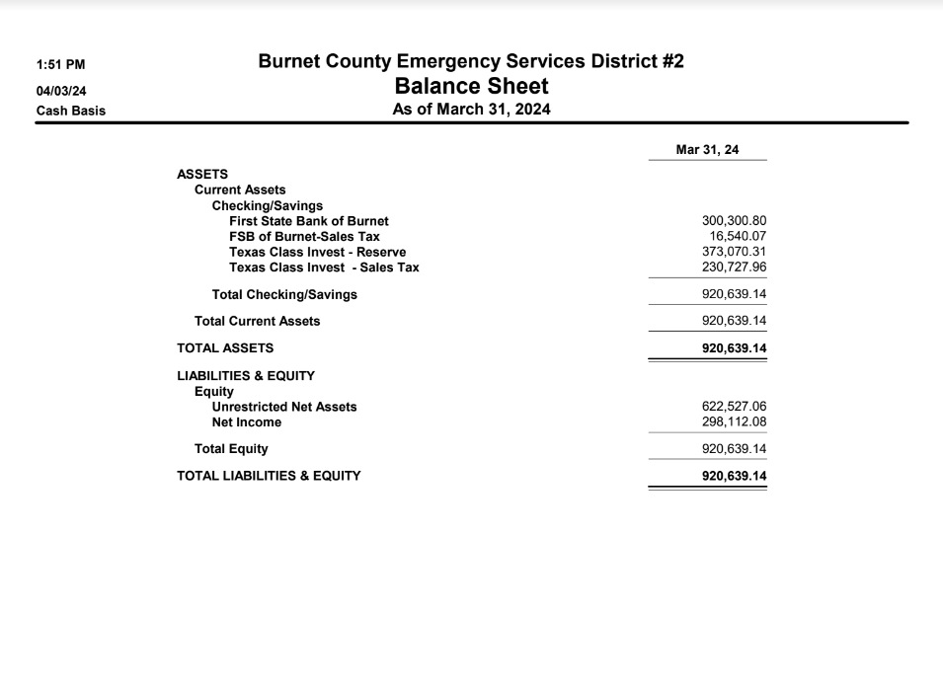
Enclosure 2

Minutes

BCESD #2

April 18, 2024

Page 8 of 31

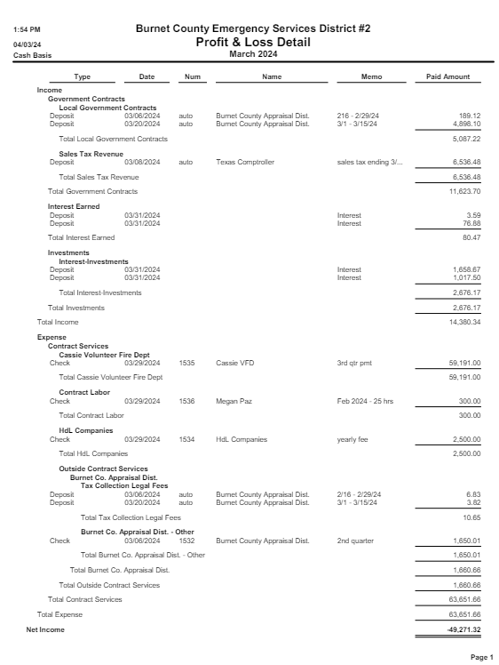
Minutes

BCESD #2

April 18, 2024

Page 9 of 31

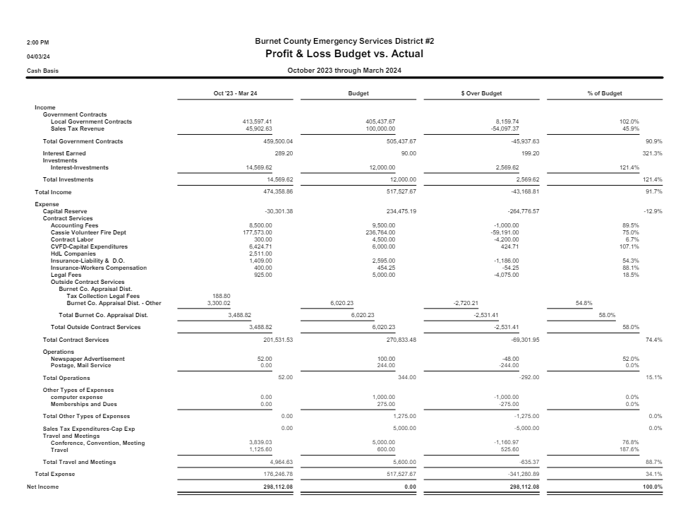
Minutes

BCESD #2

April 18, 2024

Page 10 of 31

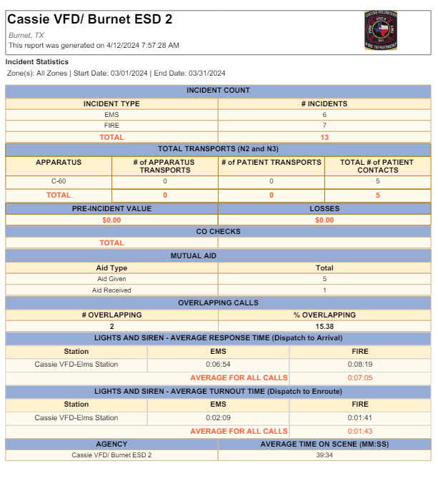
Enclosure 3

Minutes

BCESD #2

April 18, 2024

Page 11 of 31

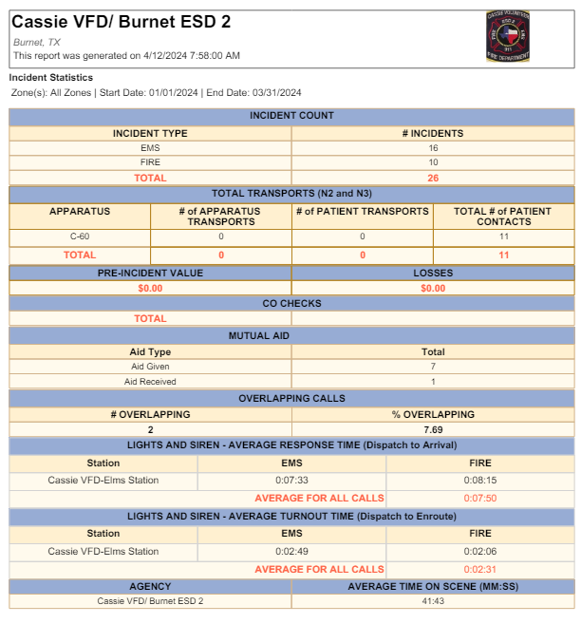
Minutes

BCESD #2

April 18, 2024

Page 12 of 31

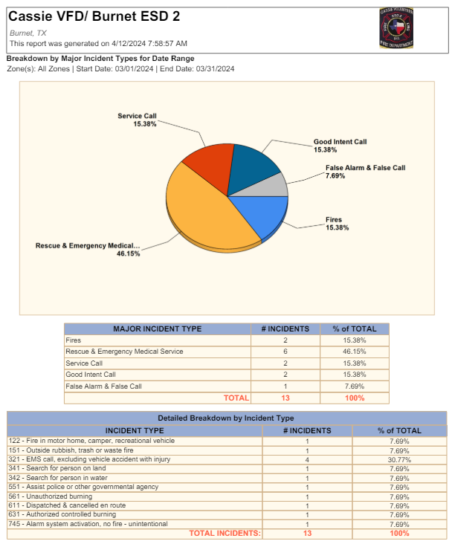
Minutes

BCESD #2

April 18, 2024

Page 13 of 31

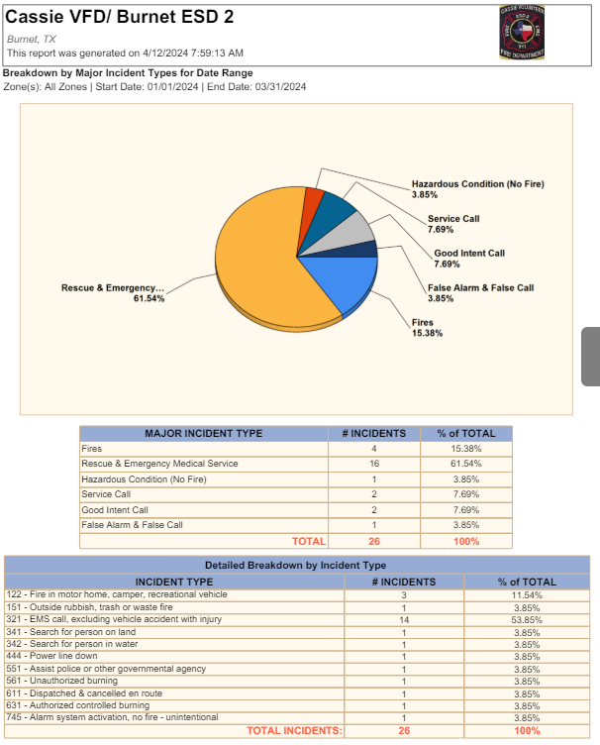
Minutes

BCESD #2

April 18, 2024

Page 14 of 31

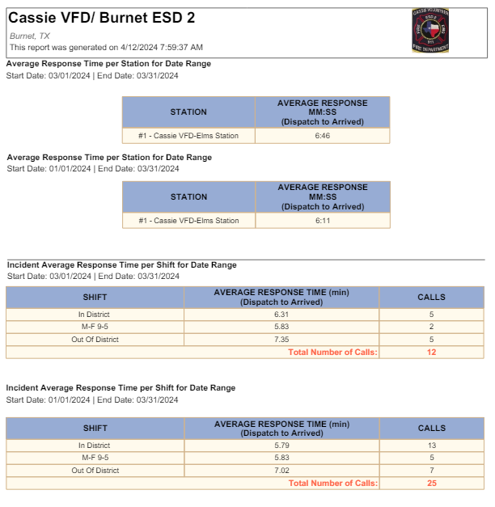
Minutes

BCESD #2

April 18, 2024

Page 15 of 31

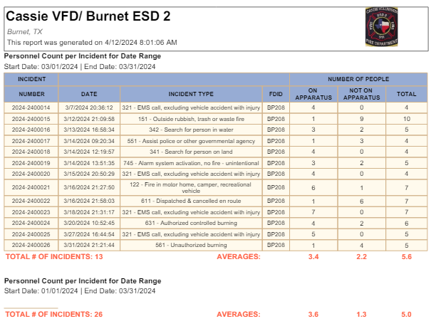
Minutes

BCESD #2

April 18, 2024

Page 16 of 31

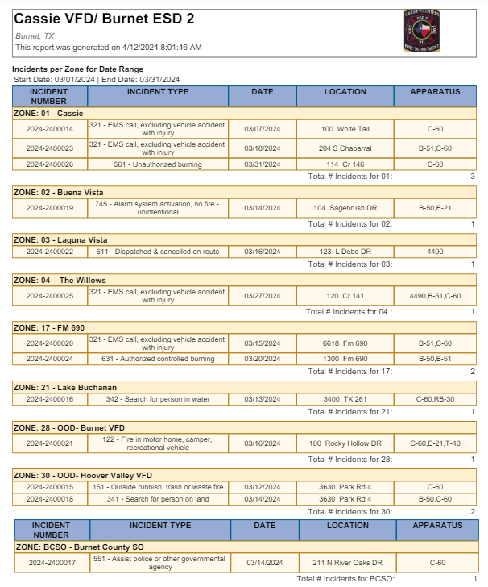
Minutes

BCESD #2

April 18, 2024

Page 17 of 31

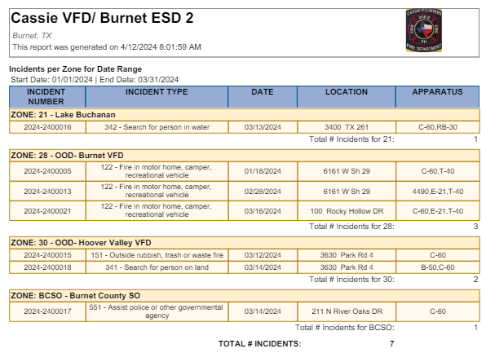
Minutes

BCESD #2

April 18, 2024

Page 18 of 31

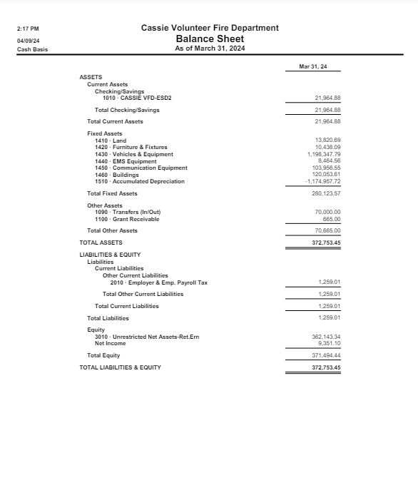
Enclosure 4

Minutes

BCESD #2

April 18, 2024

Page 19 of 31

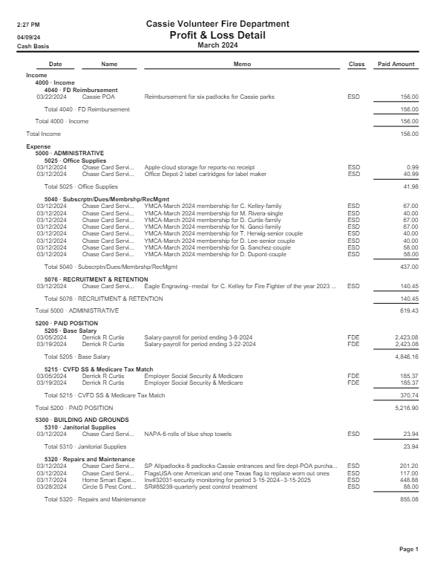
Minutes

BCESD #2

April 18, 2024

Page 20 of 31

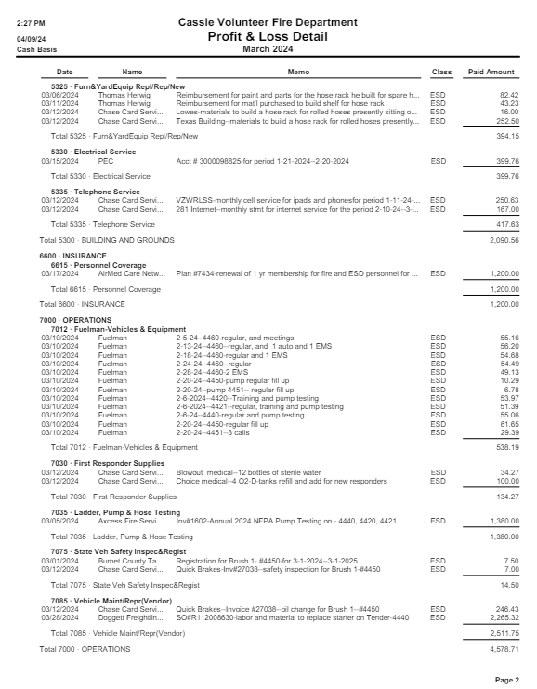
Minutes

BCESD #2

April 18, 2024

Page 21 of 31

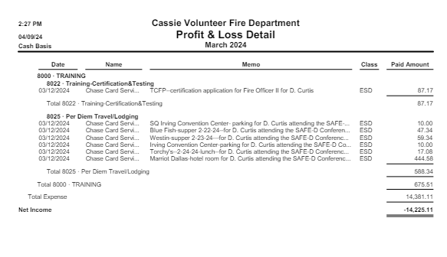
Minutes

BCESD #2

April 18, 2024

Page 22 of 31

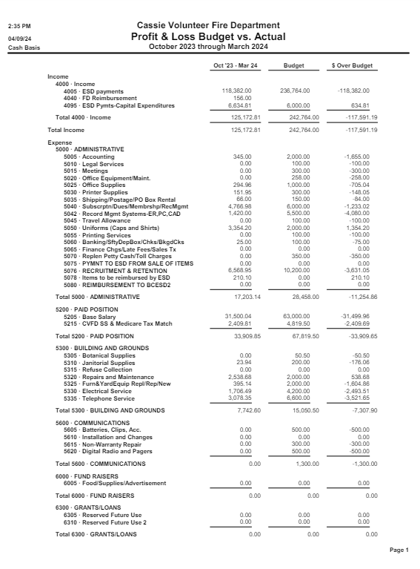
Minutes

BCESD #2

April 18, 2024

Page 23 of 31

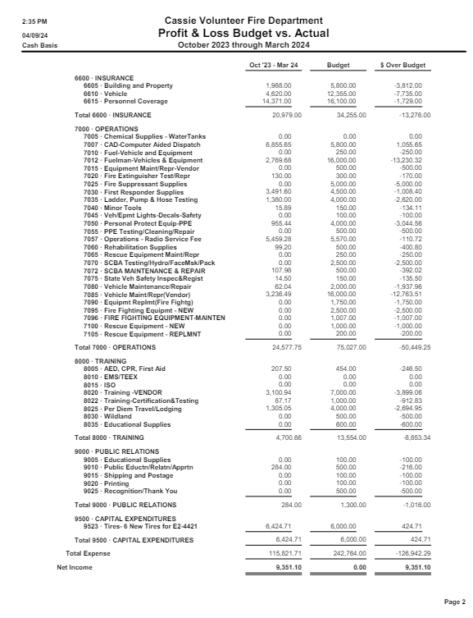
Minutes

BCESD #2

April 18, 2024

Page 24 of 31

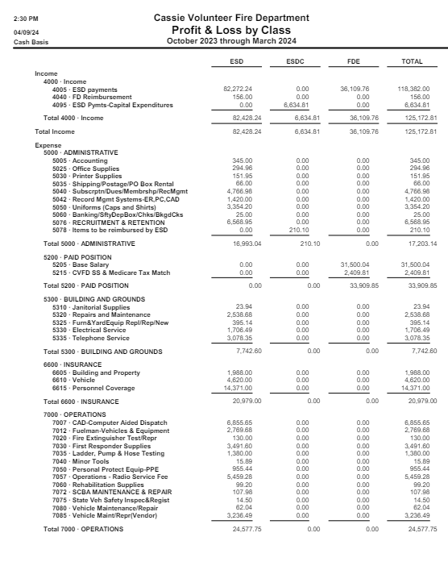
Minutes

BCESD #2

April 18, 2024

Page 25 of 31

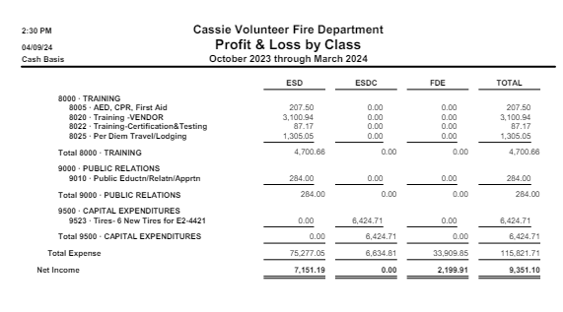
Minutes

BCESD #2

April 18, 2024

Page 26 of 31

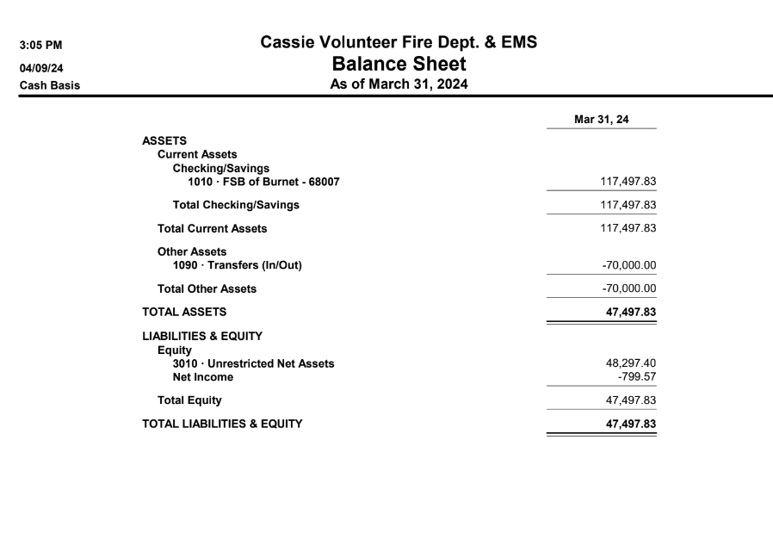
Minutes

BCESD #2

April 18, 2024

Page 27 of 31

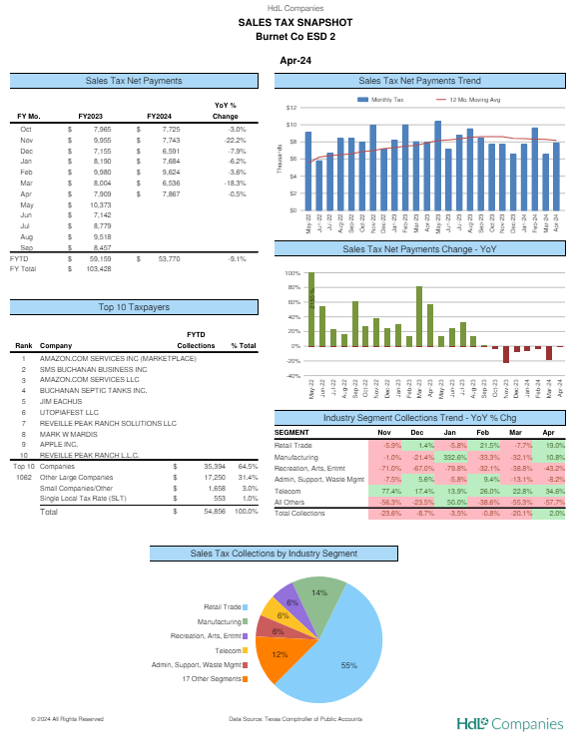
Enclosure 5

Minutes

BCESD #2

April 18, 2024

Page 28 of 31

Minutes

BCESD #2

April 18, 2024

Page 29 of 31

Minutes

BCESD #2

April 18, 2024

Page 30 of 31

Minutes

BCESD #2

April 18, 2024

Page 31 of 31

